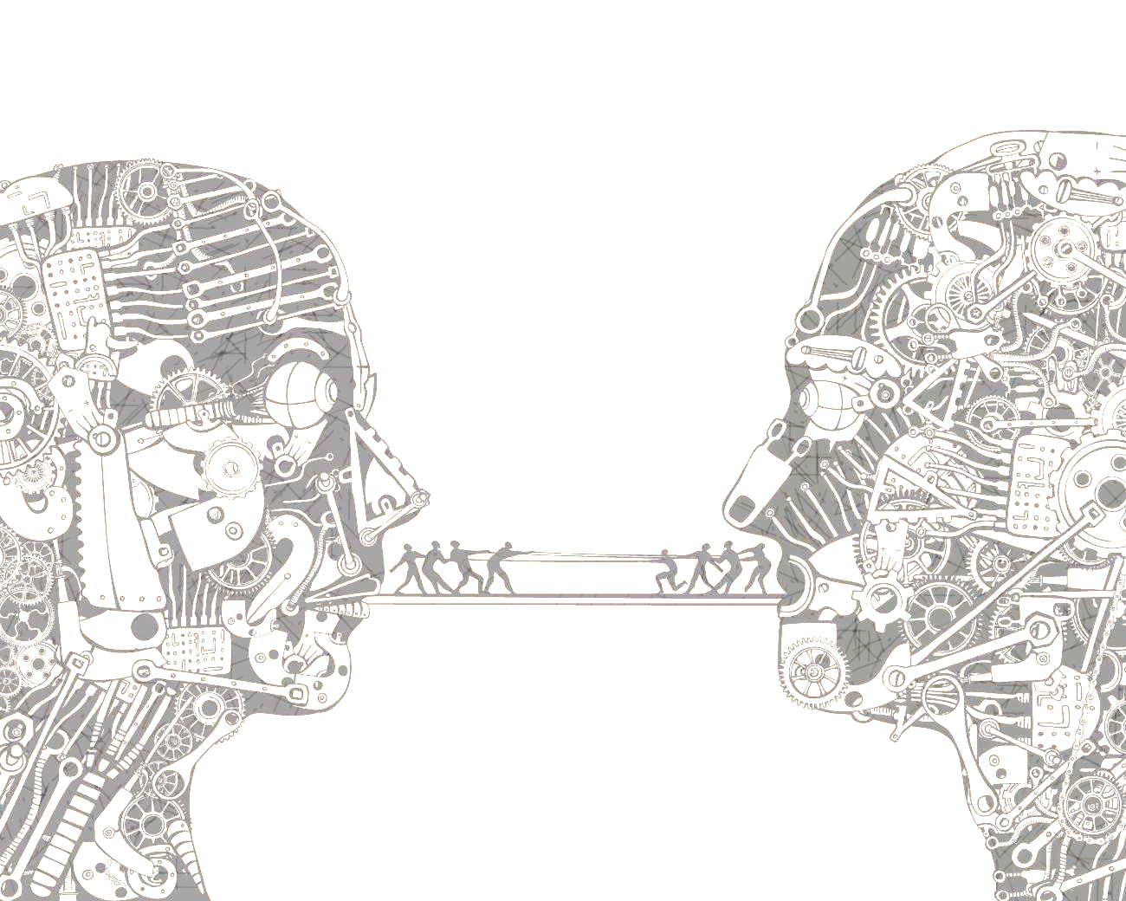
Essential Skills:
- Thesis Statement
- Sentence structure and grammar
- Organization and style
- Evidence and commentary (must have at least 3 sources)
- Speaking and listening
Driving Question
- How does the American teenager determine what is true?
Deliverables:
Persuasive Essay: Each student will write a persuasive essay on his/her chosen topic. Students will do research and cite evidence that defends his/her stance. The essay will not be your typical 5 paragraph paper, but a written work in the style of a college paper. It’s time to venture and break away from the traditional format!

Debate: To end the project, students will be required to debate their stance on their chosen topic. Students will be working collaboratively throughout the project to prepare for the debate. Be sure to use your essay and research to guide your debate preparation.

Deliverable | Date | Signature
Brainstorm | Aug. 24/25
Outline | Aug. 26
Thesis | Sept. 2
First Draft | Sept. 16
Debate Outline | Sept. 26/27

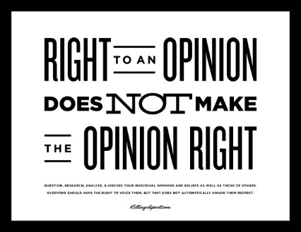
Debate Outline
Introduction Paragraph:
Hook:
Thesis

Evidence – Examples - Details
Conclusion:

Counter argument
Topic Sentence: Some may argue…
Reason #1 Topic Sentence:
Reason #2
Topic Sentence:

Below is a list of information you must gather when using a source. You must fill in all the information to get full credit. You must have at least ONE print source (book, journal, etc.)
Citation Information
Print Source_____
Title:

Author:

Editor:

Copyright Date:

Publisher:

City:
Web Source _______

Article Title:

Website Title:

Web Address:

Copyright date:

Date Accessed:

Web Source ___
Author:

Article Title:

Website Title:

Web Address:

Copyright date:

Date Accessed:
Web Source ___
Author:

Article Title:

Website Title:

Web Address:

Copyright date:

Date Accessed:

Brainstorm
Topic/prompt:
Opinion (what is your stance? Pro or con?):

Supporting Points
Reason #1

Reason #2

Counterargument (some may argue that…)

Outline
Introduction Paragraph:
Hook:
Thesis

Evidence – Examples - Details
Conclusion:

Counter argument
Topic Sentence: Some may argue…
Reason #1 Topic Sentence:
Reason #2
Topic Sentence:

