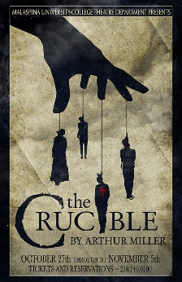
Name:___________ _________________ Date:______________
Reading Log: The Crucible by Arthur Miller

Directions: Each day after reading you will write about the scenes and acts from The Crucible by answering the questions.
You must completely answer each question exhaustively to receive credit. The questions are very specific for each chapter and require you to analyze the events, characters, and cultures of the play. For each question, you must be very clear and show you have a deeper understanding of the play.
You must complete all of the questions to receive the points. Each question is worth 5 pts for a grand total of 60pts. In addition, there is a essay response question worth 15 pts that you must complete after finishing the book.
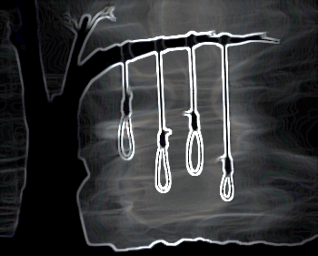

Act 1

Vocabulary:

1.

2.

3.

Chapter questions:
- Why does Abigail “admit” that Tituba and Ruth were conjuring spirits? Why is Abigail afraid the others will confess what they were doing in the woods? How does Abigail treat the other girls? How does she treat her uncle?

- What are Abigail’s feelings towards John Proctor? Why does she tell John what happened to Betty?

- Why does Abigail accuse Tituba? Why does Hale believe Abigail rather than Tituba? How does he lead Tituba into naming names?

Analysis Question:
Using evidence from the text, write a paragraph (similar to a body paragraph of an essay) in which you analyze Abigail and the type of person she is.

Act 2

Vocabulary:

1.

2.

3.

Chapter questions:

- How does Proctor feel about the court and Mary Warren’s part in the proceedings? How has Mary Warren changed?

- How has Hale changed since his arrival in Salem? Why is he testing Proctor and Elizabeth? Why hasn’t Proctor been in church?

- Why does Proctor insist that Mary Warren testify in Elizabeth’s defense? Why does Mary Warren refuse?

Analysis Question:
John Proctor obviously has strong opinions about his town’s culture and the church, but seems to be alone. Do other characters share the same feelings or do they all agree with the culture? Use evidence from the text to support your answer (similar to a body paragraph in an essay).

Act 3

Vocabulary:

1.

2.

3.

Chapter questions:

- Why is Giles Cory expelled from court? Why won’t Danforth hear his evidence? Why is Cory arrested?

- What is the professed purpose of the court? Why doesn’t the court need witnesses? What does this suggest about the proceedings?

- How is Elizabeth’s testimony used against Proctor? Why is this an unfair test of Elizabeth’s word against John’s?

Analysis Question
Write a paragraph in which you analyze Elizabeth’s intentions when she testifies and if she did the right thing. Be sure to use evidence from the text to support your answer (similar to a body paragraph of an essay).

Act 4

Vocabulary:

1.

2.

3.

Chapter questions:

- Why doesn’t the news that Abigail and Mercy have left town affect the decision of the court? How is Danforth a victim of his own logic?

- Why does Danforth allow Elizabeth to speak to John Proctor? How has she changed toward her husband? Why doesn’t she take Hale’s advice?

- Why does Proctor confess? Why will he not name names? Why will he not let Danforth have his signed paper?

Analysis Question

Although he did a terrible thing, is John Proctor a good person? Did he make the right decision in the end, or was it not effective. Use evidence from the text to support your answer (similar to a body paragraph in an essay).

