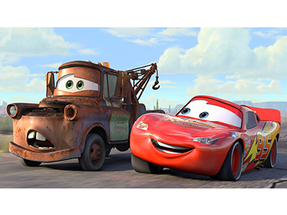

Examples

**Personification:**

Giving _______________ characteristics to things, _______________, or ideas.

**Hyperbole:**

*an _______________________

\***used to ________________ effect. It is not used to __________________the reader, but to emphasize a point.**

Examples:

Your Own Examples:

Your Own Examples:

Why is FIGURATIVE language important?