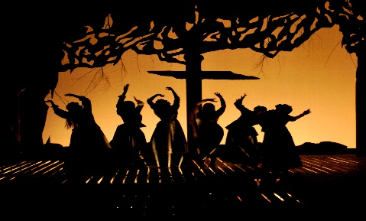
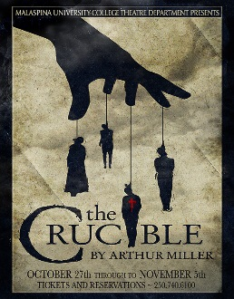
Arthur Miller 1915-2005
- Father was successful business owner, but lost everything during the __________________________.
- Depression had a ___________________ impact on the development of his social ________________________.
- Miller condemned the American ideal of _____________________ on the grounds that few can pursue it without making dangerous ______________________ compromises.
- Let’s take a closer look at this quote. In the box below, analyze this particular quote and what you thing Miller meant.
_________________________________________________________________________________________________________________________________________________________________________________________________________________________________________________________________________________________________________________________________________________________________________________________________________________________________________________________________________________________________________________________________________________________________________________________________________________________________________________________________________________________
The Red Scare
- Shortly after the end of World War I, a “___________________” took hold of the nation. Named after the red flag of the USSR (now Russia), the “Reds” were seen as a threat to the ___________________ of the United States.
- Fear, paranoia, and hysteria gripped the nation, and many __________________ people were questioned and then jailed for expressing any view which was seen as anti-Democratic or anti-American.
McCarthyism
- Senator Joseph McCarthy conducted Senate hearings that were supposed to flush out _________________communists from government and other areas of American life, including the ____________.
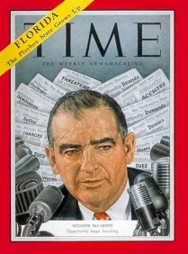
- The “________________” entertainment industry was a major target.
Strategy of McCarthyism
- Scare people in to _________________ confessions, attempting to save themselves.
- This would create the image that the U.S. was __________________with Communists, and perpetuating the hysteria.
- They would then force these people to submit a ______________ list of names of other individuals who were “associated” with the communist party.
The Effect on Miller
- Miller was asked to testify, but refused to admit any __________________ doing as well as point fingers (give list of names).
- Over 300 entertainers were placed on a _________________ for possible communist views and were thus forbidden to work for major Hollywood studios (many of these were writers).
- Arthur Miller was one of those blacklisted.
Salem, Massachusetts, 1692
- Early in 1692, a small group of girls in ___________ fell ill, falling victim to hallucinations and seizures.
- In extremely religious ____________ New England, frightening or surprising occurrences were often attributed to the devil or his cohorts.
- The unfathomable sickness spurred fears of _________________, and it was not long until the girls, and many other residents of Salem, began to accuse other villagers of consorting with the _______________ and casting spells.
- Within a few weeks, dozens of people were in jail on charges of witchcraft. The hysteria lasted from May to September of 1692. By the time it was over, ________people (and two dogs) had been convicted and hanged for witchcraft, one elderly man was pressed to death by stones, and 150 prisoners were awaiting trial. Five more people died in prison.
Parallels Anyone?
Jot down some of the parallels of the Red Scare and McCarthyism to the Salem Witch Trials.
____________________________________________________________________________________________________________________________________________________________________________________________________________________________________________________________________________________________________________________________________________________________________________________________________________________________________________________________________________________

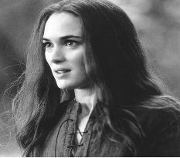
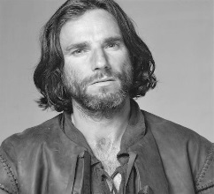
An orphan and Rev. Parris' 19-year-old niece, she leads the other girls in the accusations. She has recently been fired from the service of the Proctors after Elizabeth discovers she and Proctor were having an affair.

He is outspoken and well respected. He has stopped going to church and wrestles with telling the truth or protecting his wife Elizabeth.
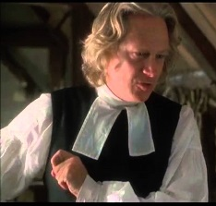

Salem’s minister who has not found popularity in the small town, especially with John Proctor.

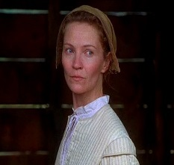
John's wife who has discovered his affair. She is a virtuous woman but struggles to show Proctor affection after her discovery.

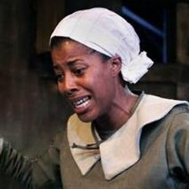

Rev. Parris' slave from Barbados who has taught the girls about spirits.

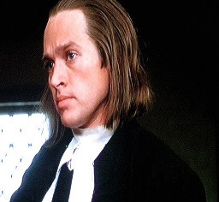
A self-appointed expert on witchcraft, he is the minister who is first called in to investigate the happenings in Salem.

A mean spirited and wealthy landowner who covets his neighbors' property. He is accused of coercing his daughter to accuse people in order to gain their land.

