Portfolio Brief

Driving Question: How can we create a non-profit organization dedicated promoting civil rights in order to achieve the American Dream?

Portfolio Deliverables:
- A 8-10 Page Paper addressing the above components (Graded by History/English Teachers)
- Visuals
  - A booth at exhibition with visuals from ALL 3 of your classes promoting your Non-Profit. The Booth will be aimed at promoting your Social Action Strategy among potential donors!
  - Visuals integrated into portfolio
  - Active participation in exhibition
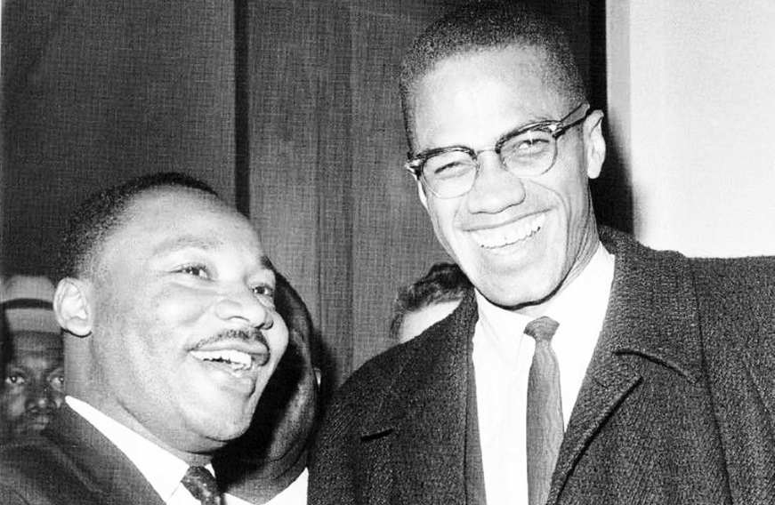

Portfolio Components
Research and Diagnosis (3 pages) - A detailed social, political, and economic diagnosis of the challenges your group faces today:
  - History: Research the unique history (SPIE) of your target community. Demonstrate the challenges faced and the change over time.
  - Create a diagnosis of the social, economic and political challenges your group faces
Business Plan
- Mission Statement and Core Values
- Branding Design
Social Action Strategy (3-4 Pages)
- Historical Case Study – Choose a Historical civil rights movement to study. Identify their goals, methods, and evaluate their success.
- Action Plan - Application of Case Study to your group - Use historical knowledge of social action strategies to combat your group’s unique challenges
  - Social - How will you gain the attention of the nation through Media?
  - Economic – How will you address the economic problems of your target community?
  - Political – What type of government and public policies are you calling for? (Laws?)

Diagnosis - the identification of the nature of an illness or other problem by examination of the symptoms.

