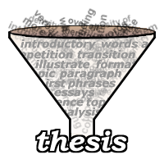
Why, Mr. E?
- A thesis statement allows you to better _______________ and develop your argument.
- It provides your reader with a “__________________” to your argument.
- It’s the one sentence that tells the reader what the whole paper is about.
What is it, Mr. E?
- A thesis statement presents your ________________ or thoughts on a subject or an issue. You cannot write an essay without one.
- A thesis statement must contain a ________________ + an opinion
- A thesis statement _______________the topic question/prompt
What Makes it good, Mr. E:
- _________________: it should be no longer than one sentence, regardless of essay length.
- Limited to one __________________ idea
- Does not use loaded language (emotionally charged language).
- A __________________ sentence with no qualifiers
  - Might, maybe, perhaps, etc.
A thesis statement should NEVER contain the following:
- in my _______________
- I _______________
- I believe

Don’ts
- In my opinion, I think, I believe, etc.
- Maybe, might, perhaps, etc.
- This essay will be about…
- A question

Do’s
- Subject + your opinion
- One main idea
- Addresses prompt
- Declarative
- One sentence
- Last sentence of intro. paragraph

What, How, or Why
- If your reader ever has to ask ____________, how, or why after reading your thesis statement, then you will have to_______________ it.
Bad Examples
- Many people object to today’s violent horror movies.
(Why? What do they object to? Why should we care?)
- Shakespeare’s Midsummer’s Night Dream is his greatest play because it is so complicated.
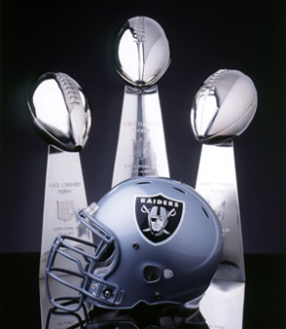
(How is it complicated? Why does that make it so great?)
Good Example
- With a rich history that promotes a commitment to excellence, the Oakland Raiders are the greatest NFL team of all time.
Examples for the Crucible essay
- Due to the mindset change of Salem and eventually the province of Massachusetts, John Proctor’s decision to be hanged was a heroic decision that left a positive impact on society.
Or
- John Proctor’s heroic decision to be hanged changed the mindset of a broken Salem and left an everlasting impact on society.
  - What: John Proctor made the correct decision to be hanged.
  - Why: Left an everlasting impact on society.
  - How: Changed the mindset of the people

