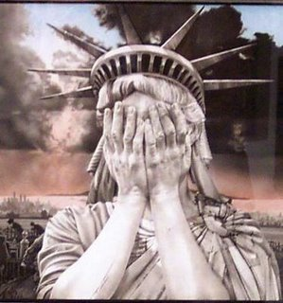
The Forgotten America

Expect poison from the standing water.
-William Blake

Driving Question: How can the “Forgotten America” flourish economically while being environmentally sustainable?

Project Description: The forgotten America greatly contributed to the election of Donald Trump. Many people have negatively labeled the forgotten America as being racist or backwards, however, the more nuanced conversation would show us otherwise. The issue for many of them wasn’t race, but more so economic opportunity. They were given hope that their outdated jobs would be reestablished as opposed to gaining the skills to succeed in 21st century opportunities. This project will investigate means to establish an environmentally sustainable economy in the forgotten America.

Deliverables:
Policy Brief:

Concise summary of a particular issue
- Select region of “Forgotten America” and identify economic struggle
- Explain why change needed
- Identify the current environmental industry opportunities and necessary skills required to obtain those jobs
Background information
- What is the root cause of the issue at hand?
- Describe the background of the region’s economic successes and ultimate downfall
- Identify/describe the industry that was once successful in the region, but is now fading/no longer exists
- Outline the environmental and technological advancements that have contributed to this decline
- Identify All Stakeholders: what are their interests? What do they need in order for their community to succeed?

Policy options and alternatives (must have a minimum of 3)
- What has been attempted in the past?
- Why should stakeholders want the change: how are you going to convince these people that alternatives are a safe bet and are right for their communities?
- Outline the advantages and disadvantages of each proposed option/alternative.
- Research examples of job creation through environmental industries and success stories.
Plan and recommendations:
- What are your ultimate recommendations to ensure this transition will happen smoothly?
- Succinctly explain your sustainable industry solution (what environmentally sustainable industry can thrive in the region – if any - and why is it better, what additional training/education do they need for this particular job, etc.)
- What steps need to be taken in order to set the stakeholders up for success?
Policy Brief Non Negotiables
- 3-4 pages in length
- Two column layout wherever applicable
- Must include graphs, boxes, sidebars, images, etc. (make your brief visually appealing)
- Minimum of five sources
- Works cited page

Pitch/presentation:
At the conclusion of the project each group will present their policy brief to a panel of professionals and teachers. Requirements are as follows:
- Present your sustainable industry solution in an engaging way
- Include visuals
- Each group member must speak
- You may present in any format
- Must cite sources

Industry categories to consider when selecting a region (blue collar):
- Manufacture
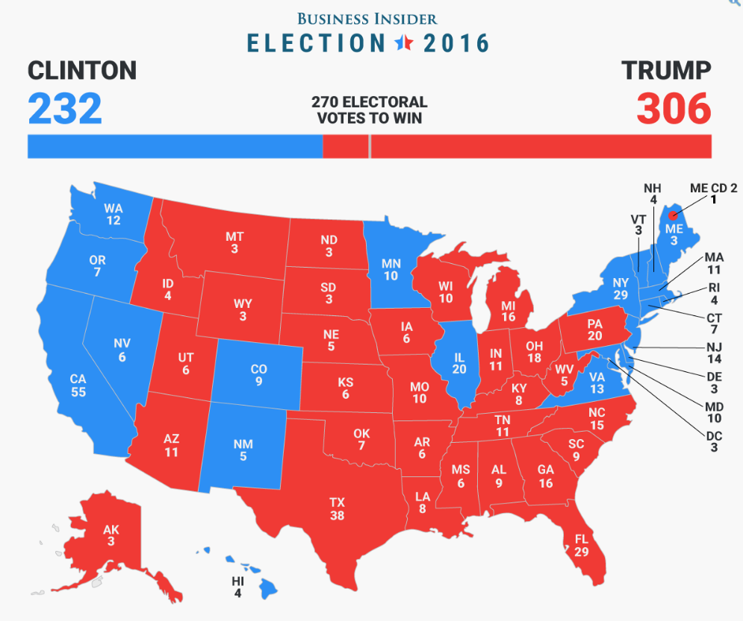
- Coal
- Fracking
- Oil/drilling
- Auto
- Agriculture
- Energy/carbon
- Nuclear
- Off shore fishing

Rubrics:
Each policy brief will be graded using the following rubrics. Keep in mind that both Laura and Eynon will be grading the policy brief, but on different skills.

English Rubric
Includes all four elements (Summary, Background, Alternatives, and Recommendations) and are mindful of structure/word choice (Denotation/Connotation) | Vivid imagery, emotional language, and/or meaningful, anecdotal evidence (Pathos)
Usage of academic language, credible sources, and precise formatting (Ethos) | At least three meaningful recommendations for solving the issue and possible outcomes
Strong references to facts, statistics, and real life examples, including visual evidence (Logos) | Includes at least 5 sources with works cited page

Biology Rubric
Data analysis: interpretation of graphs and charts, using quantitative evidence to support a claim | Abiotic Factors: Policy brief thoroughly explains how the environmental or technological change altered nonliving components of the local ecosystem (depending on your topic, you may reference biogeochemical cycles, energy, water/air/soil quality, etc.)
Ecological Interactions: Policy brief thoroughly explains how the environmental or technological change altered biotic interactions in the local ecosystem (depending on your topic, you may reference symbiosis, competition, or predation) | Sustainability: Recommendations for solving the issue consider short and long-term environmental outcomes

Brainstorm:
Select 3 regions of which your group may want to focus and then provide industry, economic, and environmental information gathered.
Region #1:_____________________________________
Main industry for region:

Impact of economy of past 20 years:

Environmental policies or technological advancements that have affected region:

Region #2:_____________________________________
Main industry for region:

Impact of economy of past 20 years:

Environmental policies or technological advancements that have affected region:

Region #3:_____________________________________
Main industry for region:

Impact of economy of past 20 years:

Environmental policies or technological advancements that have affected region:

Outline:
Now that you’ve done initial research, choose a region and gather specific information to guide your policy brief.
Region: | Industry:
Summary of issue:
- Select region of “Forgotten America” and identify economic struggle
- Why is change needed?
- Current environmental opportunities and necessary skills required

Background Information:

- What is the root cause of the issue at hand
- Background of economy success and downfall
- Industry that was once successful in region, but is now fading/no longer exists
- Environmental and/or technological advancements that have contributed to decline
- Stakeholders: what are their interests? What do they need in order for their community to succeed?

Policy Options and Alternatives (minimum of 3):

- What has been attempted in the past?
- Why should stakeholders want the change: how are you going to convince these people that this is a safe bet and is right for their communities?
- Advantages and disadvantages of each.
- Research examples of job creation through environmental industries and success stories.

Alternative #1:_________________________________________________

Alternative #2:_________________________________________________

Alternative #3:___________________________________________________

Recommendations:

- What are ultimate recommendations to ensure this transition will happen smoothly?
- Sustainable industry solution (what environmental industry can thrive in the region and why is it better, what additional training/education do they need for this particular job, etc.)
- What steps need to be taken in order to set the stakeholders up for success?

Sources:
Below is a list of information you must gather when using a source. You must fill in all the information to get full credit.
Citation Information
Print Source_____
Title:

Author:

Editor:

Copyright Date:

Publisher:

City:
Web Source _______

Article Title:

Website Title:

Web Address:

Copyright date:

Date Accessed:

Web Source ___
Author:

Article Title:

Website Title:

Web Address:

Copyright date:

Date Accessed:
Web Source ___
Author:

Article Title:

Website Title:

Web Address:

Copyright date:

Date Accessed:

Print Source_____
Title:

Author:

Editor:

Copyright Date:

Publisher:

City:
Web Source _______

Article Title:

Website Title:

Web Address:

Copyright date:

Date Accessed:

Web Source ___
Author:

Article Title:

Website Title:

Web Address:

Copyright date:

Date Accessed:
Web Source ___
Author:

Article Title:

Website Title:

Web Address:

Copyright date:

Date Accessed:

