:Colon Notes:
Huh? | Ohh…
When should I use colons? | Rule #1: A colon is used after an _____________________________________  and before a ______________ that __________________ the previous clause.  Example 1: You absolutely need a few things to go camping _________________  __________________________________________________________________  Example 2: Eynon has various hobbies __________________________________  __________________________________________________________________  Wrong use: My brothers’ names: Jeff, David, and Danny.  The use of the colon above is incorrect because ___________________________  __________________________________________________________________  Rule #2: A colon can be used before _______________, _________________,  or _________________ that _______________ or ________________ the  _______________ statement.  Example with a word:  There is one thing a human being simply cannot do without __________________  Example with a phrase:  Her goal was easily stated ____________________________________________  Example with a whole independent clause:  Luis felt that he had accomplished something good _________________________  __________________________________________________________________  Wrong use: I went to the store: I bought Hot Cheetos.  The use of the colon above is incorrect because the second clause ____________  __________________________________________________________________

;Semicolon Notes;
Huh? | Ohhh…
When should I use a semicolon? | Rule #1a: Use a semicolon to join two _________________________________  __________________ that are closely related in _________________________  Examples:  1. Great writers use the semicolon; _____________________________________  __________________________________________________________________  2. In English class we read stories; _____________________________________  __________________________________________________________________  3. I called Janet. Did you notice how windy it is? This sentence does not use a  semicolon because the two clauses are __________________________________  __________________________________________________________________  Rule #1b: Use a semicolon between __________________________________  that are joined by ____________________ such as ______________________  __________________________________________________________________  Examples:  1. English was John’s hardest subject; __________________________________  __________________________________________________________________  2. Mr. Hester’s ties are all very sophisticated; _____________________________  __________________________________________________________________  Warning!: Do ________ use a semicolon between independent clauses when they  are joined by for, and, nor, but, or, yet, or so. In those cases, use a __________  Rule #2: Use a semicolon in a __________ that uses ______________ as well.  Examples:  1. We visited Albany, New York; _______________________________________  __________________________________________________________________  __________________________________________________________________  2. Her favorite teachers are Mr. Hester, an English teacher; __________________  __________________________________________________________________  __________________________________________________________________  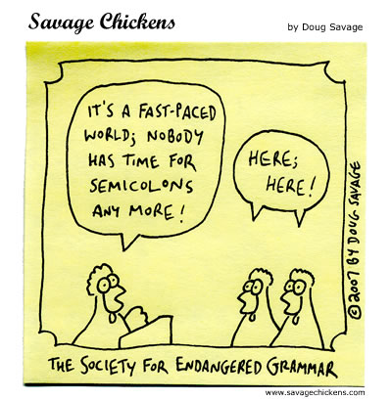

Run-On Sentences Boot Camp

A run-on sentence occurs when two _____________________ independent _________________________ are put together without an _____________________________________________________________. Sometimes the appropriate connection will be a _________________________. Other times it will be a ____________ and a word from __________________________________ (for, and, nor, but, or, yet, so). In addition, you might be able to put a _____________________________ between the two clauses if they are ____________________________________. The only way to stop writing run-on sentences is to _________________________________ getting rid of them! So let’s practice!

Part 1: Rewrite the following run-on sentences in such a way that they now work correctly. Almost all of these sentences are taken directly from students’ autobiographical narrative stories.

- Maybe I’ll be gone for half a month, I don’t know.
______________________________________________________________________________________________________________________________________________________________________________________________________________________________________________________________________________
- He took us to the kid’s room the room was awesome.
______________________________________________________________________________________________________________________________________________________________________________________________________________________________________________________________________________

- Why are you leaving us don’t you love us?
______________________________________________________________________________________________________________________________________________________________________________________________________________________________________________________________________________

Fixing Run-On Sentences

Most of the time, people make run-ons when they squish together _________________________ _____________________ , with or without a comma. To fix these, you can do one of a few things:

- Put a __________________ and a _____________________ conjunction (for, and, nor, but, or, yet, by, so) between the two clauses.
- Put a __________________ between the two clauses (don’t forget to CAPITALIZE!)
- Put a _______________________ between the two clauses (but ONLY if they are two closely related thoughts!)
Example:
WRONG: I can’t stand Miley Cyrus, I also hate Hannah Montana.

Right: I can’t stand Miley Cyrus, and I also hate Hannah Montana.
- Added ________________ and ___________________________
Right: I can’t stand Miley Cyrus. I also hate Hannah Montana.
- Added __________________ (NO conjunction)
Right: I can’t stand Miley Cyrus! I also hate Hannah Montana.
- Added _________________________________ (NO conjunction)
Right: I can’t stand Miley Cyrus; I also hate Hannah Montana.
- Added _______________________ because Hannah Montana and Miley Cyrus ARE closely related.

