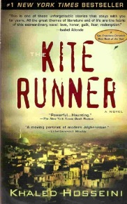
Author: Khaled Hosseini
- Born: March 4, 1965
- ______________, Afghanistan
- Father was diplomat and mother was a _______________.
- Moved to France at age 11 and never able to return to Kabul due to _________________.
- Family was given asylum in U.S. and moved to California.
- Didn’t return to Afghanistan until he was 38 years old.
- Went to ___________________school and became doctor for 10 years.
- Quite when the Kite Runner became a success… He gone!!!
Afghanistan
- ____________________ diverse country.
- As of July 2007, there were approx. _________ million people.
- About 99% of the population is ______________, and of these Muslims, 84% belong to the Sunni sect.
- Many ethnic groups have not had a strong _________________within the society.

The Taliban
- 1996 – Taliban seize control of Kabul and introduce hardline version of Islam.
- They were the sons of Afghan refugees in ________________ and
attended Pakistani schools of theology
- Only three countries recognized the Taliban government:
_________________, the United Arab Emirates, and Pakistan
- The Cold War, between the _______________ and the
former Soviet Union brought death and utter destruction to
the country.
- Over 5 million Afghans abandoned their homes and went
into exile in other countries.
- Close to 1.5 ________________ lost their lives
- Many left their homes for secured areas of the country.

Characters
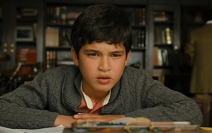
Amir: He is protagonist and narrator of the novel, a wealthy boy who grows up in Kabul, Afghanistan along with his father, Baba. Amir abuses his privileges over his servant and loyal friend, Hassan, and then fails to come to his aid. The rest of the novel deals with Amir’s guilt, his growing maturity (as he and Baba move to the U.S.), and his quest for redemption.
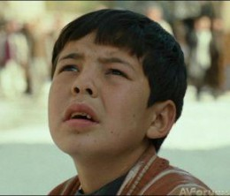
Hassan: Amir’s childhood playmate and companion, a Hazara boy with a cleft lip. Hassan is an excellent kite runner, and is naturally intelligent, but illiterate because of his social class. He is always loyal to Amir, even when Amir betrays him. Hassan eventually marries Farzana, and has a son named Sohrab.
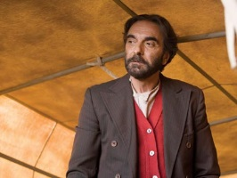
Baba: Amir’s father, a larger-than-life figure with wild hair and a loud voice, who works hard and succeeds at all of his endeavors, but stands by his strict moral principles. Baba has a huge secret/sin. Baba’s many works of charity and the orphanage he builds are part of his attempts to redeem himself.
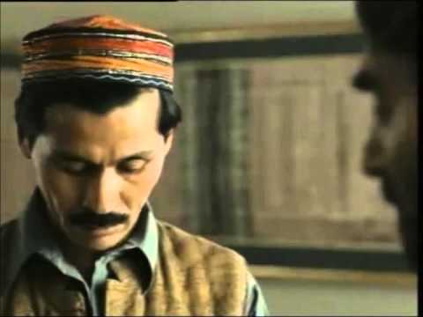
Ali: Hassan’s father, a Hazara who was orphaned as a boy and then taken in by Baba’s father and raised as Baba’s playmate and servant. The lower half of Ali’s face is paralyzed, and he was crippled in one leg by polio, but Ali remains cheerful and kind.

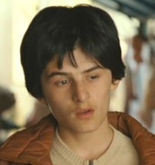
Assef: The antagonist of the novel, a blue-eyed, sadistic boy who idolizes Hitler, torments children with his brass knuckles, and does something horrific. As an adult Assef joins the Taliban.

Soraya: The daughter of General Taheri. As a young woman Soraya ran away with an Afghan man, “dishonoring” herself. Amir falls in love with her and they get married, and Soraya later becomes a teacher.

Rahim Khan: Baba’s close friend and business associate, a kind man who often seems to understand the young Amir better than Baba does. Rahim Khan encourages Amir’s writing, and as an old man he summons Amir back to Afghanistan for a chance to redeem himself by rescuing Sohrab from Afghanistan.
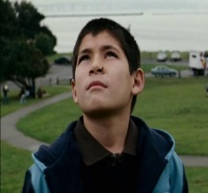
Sohrab: Hassan’s son. We meet him later in the novel as Amir ventures back to Afghanistan.

