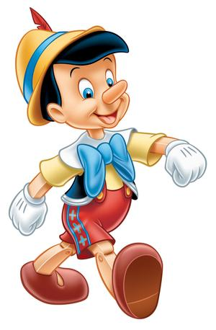
Characterization

- Characterization is a crucial part of making a story _______________________.
- In order to ______________________ and move readers, characters need to seem real.
- Good characterization gives readers a strong sense of characters' ___________________ and complexities; it makes characters vivid, alive and _____________________.

Characterization is:

One way to remember all the different characterization techniques authors use is the acronym STEAL.

Authors show what characters are like by describing their….

S

T

E

A

L

Always remember to think, ____________ is the author telling me this? What does this mean about the _____________________?

For example, in The Cat in the Hat by Dr. Seuss, one of the Cat’s actions is to balance seven objects on top of each other while standing on a ball.

What is the effect of this characterization? What do you know about the Cat?

