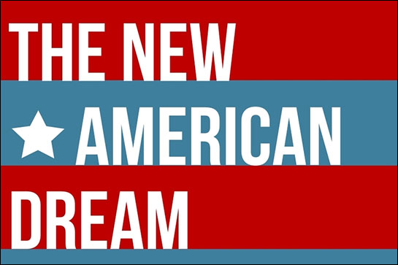

Booth Sketch: You will be given two class tables; however, the rest is up to you. Have fun and be creative
Each item listed below must be visually presented at your booth the night of exhibition. Remember, your goal is to attract potential donors, so make sure your displays are aesthetically pleasing.

Bring your portfolio to life!
- Portfolio Binder (show audience the process)
- Banner/poster with Logo and organization’s name
- Slogan
- Mission statement and core values
- Social action strategy as a creative visual
- Civil Rights data and statistics
- Portfolio
- ________________
- ________________
- ________________

Booth Checklist
Front View
Above View

